Ontario Tenpin Bowling Association

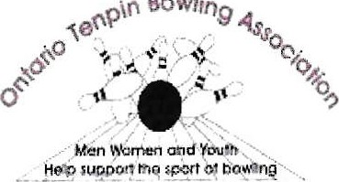

Bowling

www.otba.ca

# 2023-2024 HIGH AVERAGE WINNERS

|  |  |  |  |  |
| --- | --- | --- | --- | --- |
| Division | First Name | Last Name | Association | Averaqe |
| Bantam Girl | Ellie | Caille | WECKBA | 117 |
| Bantam Boy | Grayson | Earnshaw | London & District | 119 |
| Prep Girl | Izzabell B. | Saunders | WECKBA | 127 |
| Prep Boy | Aaron | Bizier | Gr. Toronto | 166 |
| Junior Girl | Emily | Eggett | Gr. Toronto | 158 |
| Junior Boy | Gavin | Shay | WECKBA | 188 |
| Intermediate Girl | Samantha | Cirillo | Gr. Toronto | 206 |
| Intermediate Boy | Rowan | Squire | Niagara TBA | 208 |
| Senior Girl | Mya | Conway | Niagara TBA | 190 |
| Senior Boy | Brayden | Vaughan | South Central ON | 223 |
| Women | Brittney | Spearing | Gr. Toronto | 228 |
| Men | Dan | MacLelland | South Central ON | 239 |